Pokhara University

Level: Bachelor | Semester – Fall | Year : 2011
Programme: BE |  | Full Marks: 100
Course: Engineering Mathematics I |  | Pass Marks: 45
 |  | Time : 3hrs.

Candidates are required to give their answers in their own words as far as practicable.
The figures in the margin indicate full marks.

Attempt all the questions.

 | - If 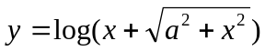 prove that .  OR  Examine the continuity and derivability at x = 0 and x =of the function f(x) defined as follows:  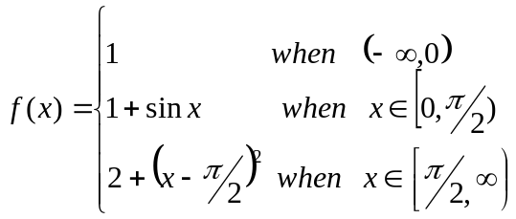  - State and prove Langrange’s Mean Value theorem. What is its geometrical meaning? | 8  8  7
 | - State L. Hospital’s theorem. Evaluate 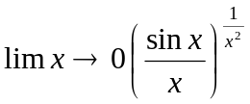  - The strength of beam varies jointly as its breadth and square of the depth. Find the dimension of the strongest beam that can be cut from a circular wooden log of radius a.  OR  Find the asymptotes of the curve x²(x - y)² - a²(x² + y²) = 0.  Integrate any three of the following | 7  8  8
 | - 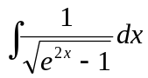  - 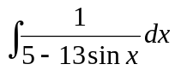  - 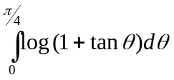  - 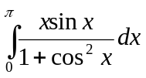 | 3×5
 | - Show that the area of astroid 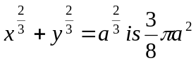.  - Obtain the volume of the solid in the first quadrant bounded above by the curve 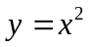, below by x-axis and on the right by the line 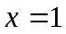 about the line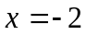.  OR  Approximate the integral 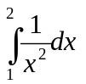with n=4, using Trapezoidal and Simpson’s rule and compare the result with exact value. | 7  8  8
 | - Find by vector method the equation of plane through the points (2, 4, 5), (1, 5, 7), and (-1, 6, 8).  - Define Vector Triple Product and show that the vectors 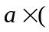×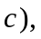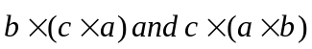 are coplanar. | 8  7
 | - Obtain the vertices, centre, coordinates of foci, eccentricity of the following ellipse: 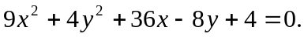  - Show that the line lx + my + n = 0 touches the hyperbola 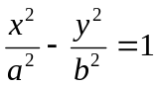 if 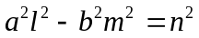. | 7  8
 | Answer the following questions:  - Find the radius of curvature at 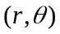 for 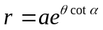  - Find the domain and range of the function y=3 + sinx  - Find the vector projection of  - What will be the arc length of the curve 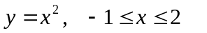  - Find equation of tangent at (2,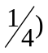on the parabola y²= 16x | 2×5

